**IBM COGNOS EMBED CODE LINK**

|  |  |
| --- | --- |
| **Team ID** | PNT2022TMID18255 |
| **Project Name** | Corporate Employee Attrition Analytics |

**GETTING DASHBOARD LINK FROM IBM COGNOS**

**LINKING IN WEBAPP**

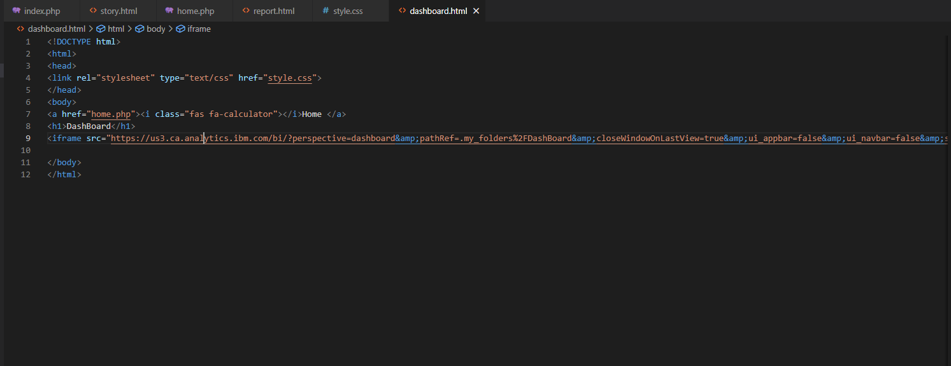

**GETTING REPORT LINK FROM IBM COGNOS**

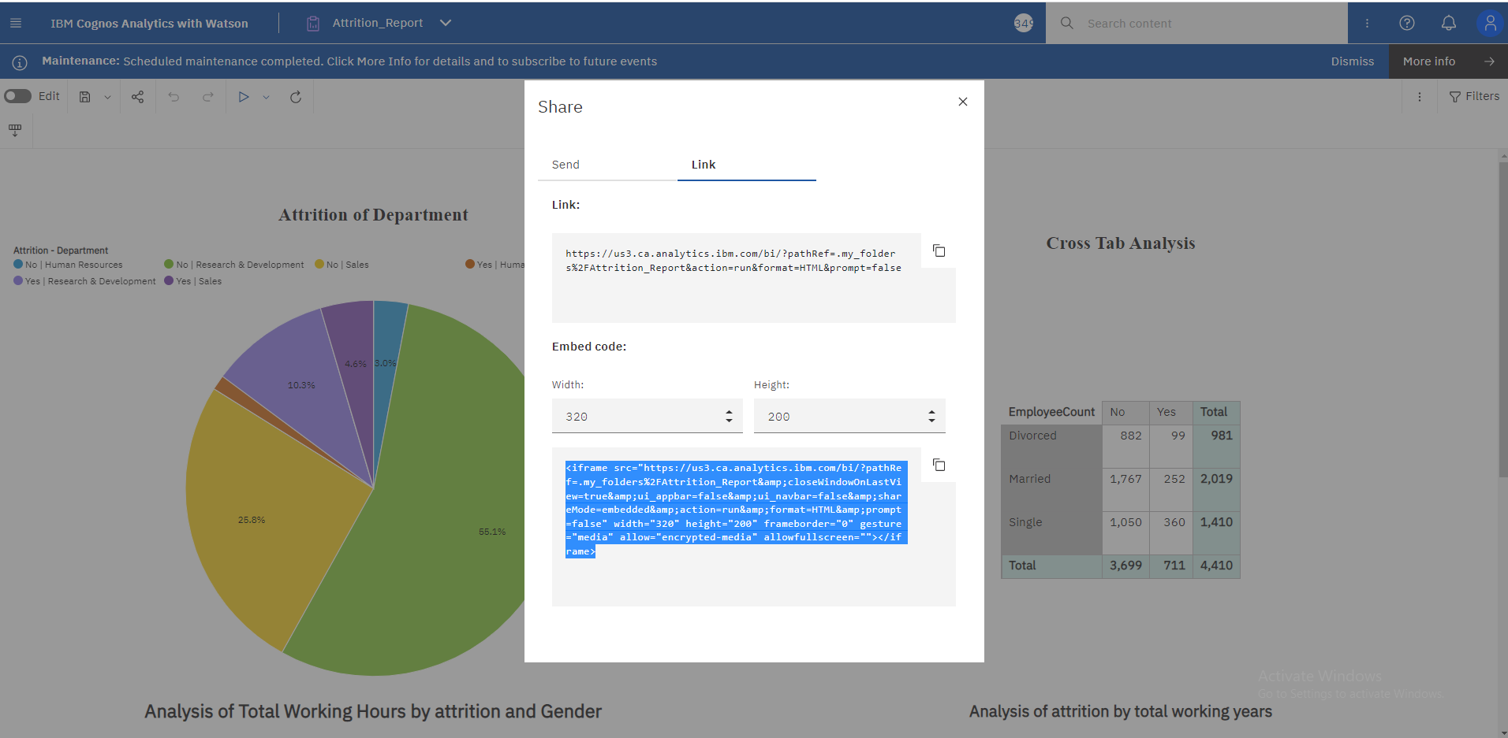

**LINKING IN WEBAPP**

**GETTING STORY LINK FROM IBM COGNOS**

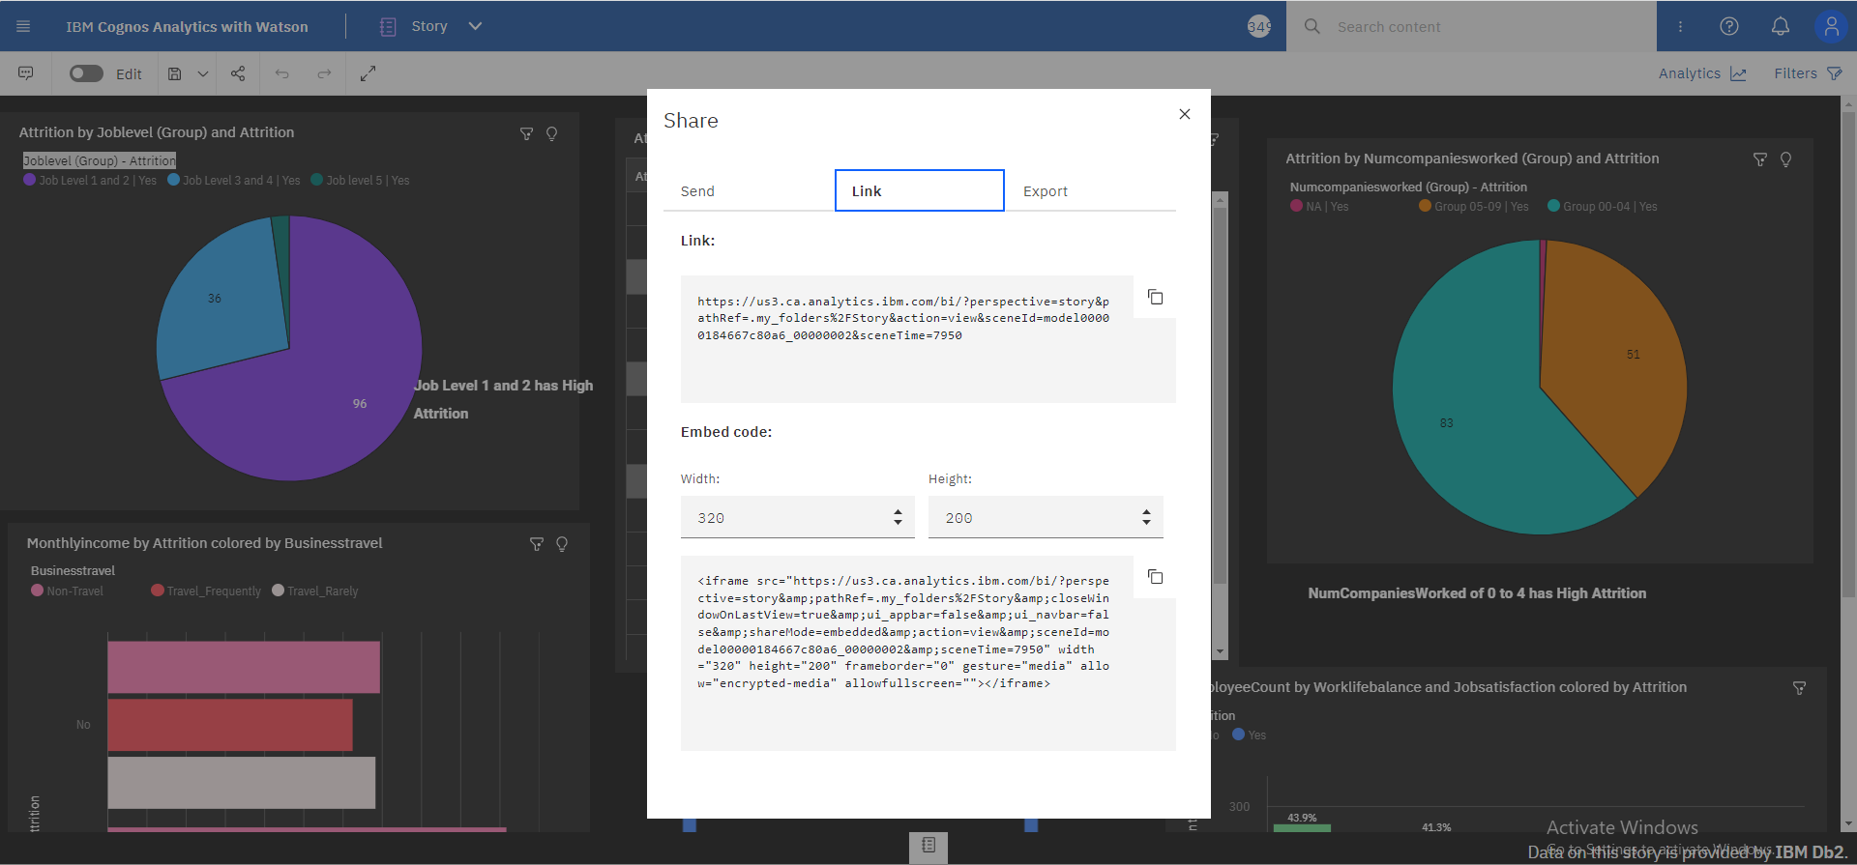

**LINKING IN WEBAPP**

